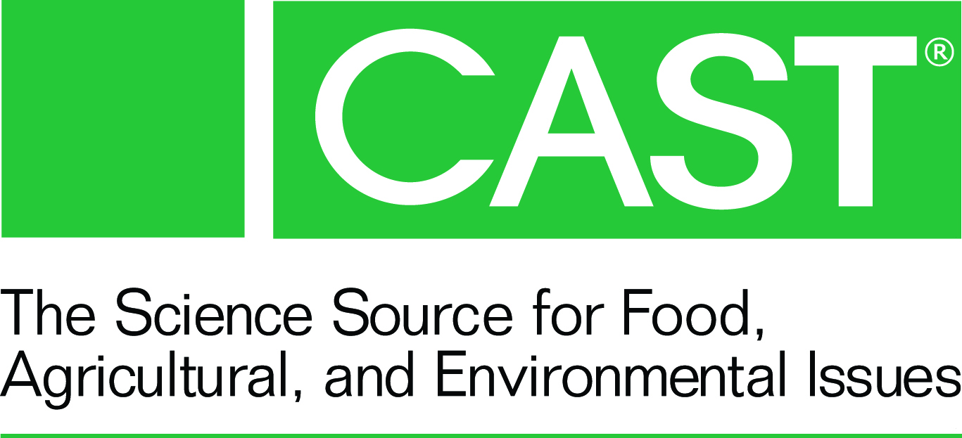
For Immediate Release

Alison Van Eenennaam Honored at the 2014
Borlaug CAST Communication Award Ceremony

Van Eenennaam Will Deliver the Keynote Speech at Today’s World Food Prize Side Event

October 15, 2014...Ames, Iowa: The Council for Agricultural Science and Technology (CAST) is presenting the 2014 Borlaug CAST Communication Award to Dr. Alison Van Eenennaam today, October 15, at a morning event in conjunction with the World Food Prize Symposium in Des Moines, Iowa. Recipients of this annual award are science/ag experts who demonstrate an ability to communicate by written material, public presentations, and various forms of media. Van Eenennaam is known for her communication skills and praised for her understanding of biotechnology, her enthusiasm for agricultural education, and her abilities to use novel ideas to get important messages to policymakers and the public alike.

Van Eenennaam will speak about "The Livestock Revolution" and other issues of interest to the agriculture community. She has given more than 250 presentations around the world and made appearances on the Dr. Oz Show, Animal Planet, and NPR. This year's award is sponsored by DuPont, with the breakfast presentation event being sponsored by DuPont Pioneer. A Food Dialogues session hosted by U.S. Farmers & Ranchers Alliance will follow the CAST program.

A faculty member and Cooperative Extension Specialist at the University of California-Davis, Van Eenennaam has been involved with 60 peer-reviewed publications, including two important CAST papers--a commentary about genetically engineered animals and an issue paper examining the potential impacts of mandatory labeling for GMO food.

Van Eenennaam has served on several national committees and won many distinguished honors. She also uses her creative talents to communicate information about science and agriculture with videos that include a documentary about animal biotechnology, a collaboration with students featuring a parody of Macklemore's "Thrift Shop," and an award-winning film clip that uses an old song to promote agricultural innovation.

With her many talents, Dr. Van Eenennaam represents the true nature of the award inspired by Norman Borlaug. One of her colleagues summed up her impact this way: "Her creativity and personal talent to engage and communicate have enabled her to illustrate the importance of technology to a broad audience including students, non-scientists, livestock producers, government officials, policymakers, regulators, and scientific peers. This is not only rare; it is truly remarkable."

Visit the CAST website at www.cast-science.org for updated information about the award and presentation.

Contact: Linda M. Chimenti, CAST Executive Vice President
Phone: 515-292-2125, ext. 231; E-mail: lchimenti@cast-science.org
www.cast-science.org

