Plant Growth Regulators for Better Phenolic Development in Cold-hardy Hybrids
Cold-hardy hybrid grape varieties are the foundation for the wine industry in the Midwest, and other regions, but making high quality red wine can be a challenge due to unique chemistry that varies from the more traditional Vitis vinifera cultivars. Many of the traits that we typically think of in high quality red wine, such as color, mouthfeel, and ability to age, are related to phenolic compounds. The most well-known of these compounds is tannin. Tannins are responsible for red wine astringency, color stability as well as resisting oxygen-related faults (Casassa & Harbertson, 2014). However, cold-hardy hybrid grapes, like ‘Marquette,’ ‘Frontenac’, and ‘Petite Pearl,’ lack tannin leading to wines that lose color, with less texture and develop off aromas due to early oxidation.
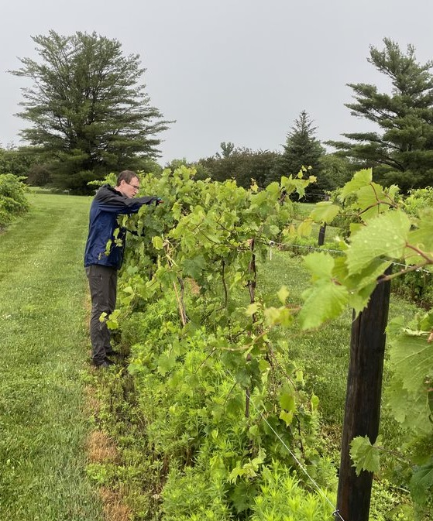
In an effort to increase phenolic compounds content and therefore red wine quality made from cold-hardy hybrids, we are looking at the effect of plant growth regulators, in combination with mowing, on Marquette over two vintages, 2022-2023. PGRs are chemicals that modify plant growth in specific ways. The two PGRs we are using are prohexadione calcium (ProCal) and phenylalanine (Phe). ProCal acts by inhibiting the formation of gibberellins which are plant hormones that promote shoot growth and cell elongation. Additionally, calcium is known to create crosslinks between pectins which are structural polysaccharides in the cell walls of fruit (Martins et al., 2020). The combination of these actions will hopefully aid in the extraction of tannins by inhibiting the binding capacity of cell wall material to tannins. Phenylalanine is used by grapevines in the biosynthesis of phenolic compounds (Broeckling 2012). We hope to encourage the biosynthesis of tannin by application of phenylalanine during berry development and ripening. Another factor that can affect vine growth is the use of cover crops and we are either keeping or mowing the grass in between rows of vines. Leaving long grass around some of the vines is aimed at encouraging development of arbuscular mycorrhizae which are like “mushroom roots” and can aid in nutrient uptake by the vine (Cheng & Baumgartner, 2004).
Figure 1. Alex Gapinski collecting grapes during berry development at the ISU Horticulture Research Station in 2022.
The PGRs were sprayed on the vine canopy throughout the growing season up to two weeks after véraison and the vineyard was mowed weekly. Every other week, we collected a sample of berries from each treatment (Figure 1) and evaluated the content of phenolic compounds in grape juice, skins, and seeds. After harvest in late August, we made small batches of wine from each panel of treated vines. We measured tannin content, color, total phenolics, skin texture, and basic chemistry like °Brix, pH and titratable acidity. By looking at the chemistry of the berries and the wine, we can make connections between what phenolic compounds the plants produced during development and ripening and what ends up in the wine. We hope to use PGRs and mowing treatments to increase phenolic compounds production and extraction, which will improve mouthfeel, color stability, and reducing the risks of oxidation.

About Alex:
Alex Gapinski is a first-year master’s student in the department of Food Science and Human Nutrition at Iowa State University (ISU). He works with Dr. Aude Watrelot on grape and wine phenolic chemistry. Alex first became interested in wine after travelling to France to study sustainable food systems during his undergraduate food science studies. This experience led him to pursue wine industry certifications such as the Wine and Spirit Education Trust Level 3 award in wines and Level 2 in spirits, the French Wine Scholar with the Wine Scholar Guild, and American Wine Expert from Napa Valley Wine Academy. Prior to graduate school, Alex used his knowledge in hospitality roles at a Wisconsin winery and as a wine lead at a liquor store chain in the Twin Cities area of Minnesota. Alex looks forward to diving deeper into wine through his master’s studies and sharing his research at the 2022 Three Minute Thesis (3MT) competition at ISU as well as at future Extension and Outreach events.

References:
Broeckling, C. D., Li, K.-G., & Xie, D.-Y. (2012). Comparative Metabolomics of Transgenic Tobacco Plants (Nicotiana tabacum var. Xanthi) Reveals Differential Effects of Engineered Complete and Incomplete Flavonoid Pathways on the Metabolome. In Transgenic Plants - Advances and Limitations (pp. 379–396). InTech. https://doi.org/10.5772/32872
Casassa, F. L., & Harbertson, J. F. (2014). Extraction, Evolution, and Sensory Impact of Phenolic Compounds During Red Wine Maceration. Annu. Rev. Food Sci. Technol, 5, 83–109. https://doi.org/10.1146/annurev-food-030713-092438
Cheng, X., & Baumgartner, K. (2004). Arbuscular mycorrhizal fungi-mediated nitrogen transfer from vineyard cover crops to grapevines. Biology and Fertility of Soils, 40(6), 406–412. https://doi.org/10.1007/S00374-004-0797-4/TABLES/3
Martins, V., Garcia, A., Alhinho, A. T., Costa, P., Lanceros-Méndez, S., Costa, M. M. R., & Gerós, H. (2020). Vineyard calcium sprays induce changes in grape berry skin, firmness, cell wall composition and expression of cell wall-related genes. Plant Physiology and Biochemistry, 150, 49–55. https://doi.org/10.1016/J.PLAPHY.2020.02.033

